Cairo University  
Faculty of Computers and Artificial Intelligent

**CS251 - Software Engineering I**

Project Name

Software Requirements Specifications (SRS)

Team Names

|  |  |  |  |
| --- | --- | --- | --- |
| **ID** | **Name** | **Email** | **Mobile** |
| 20200603 | Noor El Deen Nizar | noornizaredu@gmail.com | 01009152050 |
| 20200279 | Abdelrahman Ahmed Ali |  |  |
| 20210612 | Omar Hussien Ibrahem |  |  |
| 20200838 | Abdelrahman Hesham | abdelrahmanhesham601@gmail.com | 01157428087 |

Month & Year:

8/5/2022

Contents

Instructions [To be removed] 3

Team 3

Document Purpose and Audience 3

Introduction 3

Software Purpose 3

Software Scope 3

Definitions, acronyms, and abbreviations 3

Requirements 4

Functional Requirements 4

Non Functional Requirements 4

System Models 4

Use Case Model 4

Use Case Tables 5

Ownership Report 6

Policy Regarding Plagiarism: 6

# Team

|  |  |  |  |
| --- | --- | --- | --- |
| **ID** | **Name** | **Email** | **Mobile** |
| 20200603 | Noor El Deen Nizar | noornizaredu@gmail.com | 01009152050 |
| 20200279 | Abdelrahman Ahmed Ali |  |  |
| 20210612 | Omar Hussien Ibrahem |  |  |
| 20200838 | Abdelrahman Hesham | abdelrahmanhesham601@gmail.com | 01157428087 |

# Document Purpose and Audience

**The purpose for this document is to introduce a system for managing a parking lot**

**This project is a parking lot management system prototype that is confined to the college grounds. This was done under the supervision of college lecturers. This initiative is beneficial to both the parking lot management staff and the customers.**

# Introduction

#### Software Purpose

**This software is written to Manage parking spaces of different capacities, it provides features such as calculating parking fees and total revenue, gathering statistics such as total revenue, logging slots usage and other events.**

## Software Scope

**The system eases the parking process for the staff and the customer by having an algorithm identified by the manager for assigning the parking slots.**

**The system also calculates the parking time and the fee required, it also help the manager to gather total revenue.**

**The system display available slots and the parked vehicles.**

## Definitions, acronyms, and abbreviations

# Requirements

## Functional Requirements

* **System Will Identify a newly arriving Vehicle Based On its unique identification number and store its model name, model year, and vehicle dimensions.**
* **On arrival of a new vehicle, the system determines if there are free slots it assigns the car to a slot based on the configured method set by the Garage Manager, The system then stores the arrival time for that vehicle.**
* **On departure of a vehicle, the System calculates the Required parking fees based on calculated time-of-stay.**
* **The System Keeps track of the Total Amount of Revenue Made and the Total Number of cars parked to the Current Time and Provides the System User / Manager With the option to display them.**

## Non Functional Requirements

|  |  |
| --- | --- |
|  | **Details** |
| **Performance** | **The System Will be able to assign a parking slot to an arriving vehicle in linear time.** |
| **Scalability** | **The system should be able to support Parking Spaces with any number of parking lots** |
| **Robustness** | **The system can handle different exceptional behavior.** |
| **Supportability** | **System Can Handle Different types of vehicles Without Modifications to the code.** |

# System Models

## 

## Use Case Model

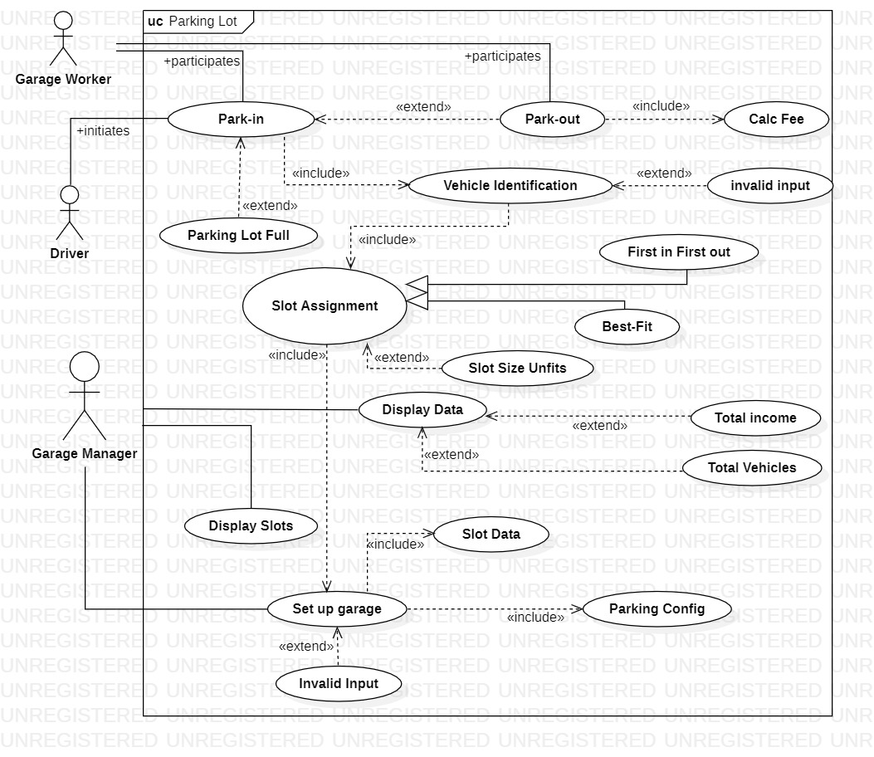

## Use Case Tables

|  |  |  |
| --- | --- | --- |
| Use Case ID: | 1 | |
| Use Case Name: | Park-in | |
| Actors: | Worker | |
| Pre-conditions: | The driver is at the Garage  The garage System is set up. | |
| Post-conditions: | The driver is allocated a parking slot. | |
| Flow of events: | **User Action** | **System Action** |
| 1- Worker Checks Screen to see if there’s an available parking slot. |  |
|  | 2- System checks if the garage is full.  3- System Display Form for Description and Identification of the vehicle. |
| 4- Worker Fills in the Form and submit it for the vehicle. |  |
|  | 5- System Assign the Driver to a slot based on configured parking method, and records arrival time. |
| Exceptions: | **User Action** | **System Action** |
| 1- Worker Checks Screen to see if there’s an available parking slot. |  |
|  | 2- System Display Message indicating that Parking Lot is Full. |
|  |  |  |
|  | 1- Worker Fills in the Form for vehicle Description and submit It [invalid input] |  |
|  |  | 2- System displays message that Input is invalid and asks for valid input. |
|  | 3-Worker Re-enters data correctly. |  |
|  |  | 4-System Display Form for Description and Identification of the vehicle. |
|  | 1- Worker Fills in the Form and submit it. [Slot size unfit] |  |
|  |  | 2- System displays message no slot available |
| Includes: | Included in this use case description Vehicle identification | |
| Notes and Issues: |  | |

|  |  |  |
| --- | --- | --- |
| Use Case ID: | 2 | |
| Use Case Name: | Setup garage | |
| Actors: | Garage Manager | |
| Pre-conditions: | Garage Information Wasn’t Added In  Or Manager Wants to modify Current Information. | |
| Post-conditions: | Update/Set Garage information. | |
|  | **User Action** | **System Action** |
| 1-. Garage Manager requests and fills owner form. |  |
|  | 2- System authorizes and confirms. |
| 3- Garage Manager fills garage setup form. |  |
|  | 4- System Updates/Sets Slot information and Confirm input. |
| 5- Garage Manager Inputs Parking Configuration method. |  |
|  |  | 6-System Sets Parking Configuration Method. |
| Exceptions: | **User Action** | **System Action** |
| 1- Garage Manager requests and fills owner form. |  |
|  | 2- System Displays Error Message “unauthorized user”. |
| Includes: | Garage Manager Must Select one of the Two Available Parking Configuration Methods, Input Must be Positive. | |

|  |  |  |
| --- | --- | --- |
| Use Case ID: | 3 | |
| Use Case Name: | Park-out | |
| Actors: | Worker | |
| Pre-conditions: | Park-in, Driver Goes to the Exit Gate System Screen. | |
| Post-conditions: | The driver Pays the required fee and leaves the garage. | |
| Flow of events: | **User Action** | **System Action** |
| 1- worker requests for a payout. |  |
|  | 2- System Verify user data and calculates the fees. |
| 3- worker gets the fees from the driver and updates the system. |  |
|  | 4- System displays confirmation message. |
| Exceptions: | **User Action** | **System Action** |
|  |  |
| Includes: | Driver is already parked in the garage. | |
| Notes and Issues: |  | |

# 

|  |  |  |
| --- | --- | --- |
| Use Case ID: | 4 | |
| Use Case Name: | Display all available slots | |
| Actors: | Manager | |
| Pre-conditions: | The manager already set up the garage | |
| Post-conditions: | Manager gets all the available slots | |
| Flow of events: | **User Action** | **System Action** |
| 1- Garage Manager requests and fills owner form. |  |
|  | 2- System authorizes and confirms. |
| 3- Garage Manager request available slots |  |
|  | 4- System displays all available slots. |
| Exceptions: | **User Action** | **System Action** |
| 1-Garage Manager requests and fills owner form. |  |
|  |  | 2- System Displays Error Message “unauthorized user”. |
|  |  |  |
|  | 1- Garage Manager request available slots. |  |
|  |  | 2-System Displays no available slots (garage full). |
| Includes: | The manager must setup the garage before requesting . | |
| Notes and Issues: |  | |

|  |  |  |
| --- | --- | --- |
| Use Case ID: | 5 | |
| Use Case Name: | Display data (total revenue, total vehicles) | |
| Actors: | Garage manager | |
| Pre-conditions: | The manager already set up the garage | |
| Post-conditions: | Manager gets all requested data (total revenue, total vehicles) | |
| Flow of events: | **User Action** | **System Action** |
| 1- Garage Manager requests and fills owner form. |  |
|  | 2- System authorizes and confirms. |
| 3- Garage Manager request to see all registered vehicles |  |
|  | 4- System displays all registered vehicles. |
|  | 5-Garage manager request to see total revenue. |  |
|  |  | 6-system displays total revenue. |
| Exceptions: | **User Action** | **System Action** |
| 1-Garage Manager requests and fills owner form. |  |
|  |  | 2- System Displays Error Message “unauthorized user”. |
|  |  |  |
|  | 1- Garage Manager request registered vehicles. |  |
|  |  | 2-System Displays no registered vehicles (no vehicle registered). |
|  |  |  |
|  | 1-Garage manager request total revenue. |  |
|  |  | 2-System displays no revenue (no vehicles parked ever) . |
| Includes: | The manager must setup the garage before requesting . | |
| Notes and Issues: |  | |

# Ownership Report

|  |  |
| --- | --- |
| **Item** | **Owners** |
| * | *\** |